Project Final Report Format

National University of Computer and Emerging Sciences, Islamabad

FAST School of Computing Science


Empowering and Nurturing Orphans
Submitted by
Moiz Ansari
Ali Sher
Muhammad Daniyal
Abdullah Siddiqui
Bachelor of Computer Science
2024
Instructor
Mehreen Iftikhar
Project Title: Empowering and Nurturing Orphans



Name, Roll No: Moiz Ansari (23i-0523)
Ali Sher (23i-0683)
Muhammad Daniyal (23i-0579)
Abdullah Siddiqui (23i-0617)

Instructor: Mehreen Iftikhar

Word Count: 4138

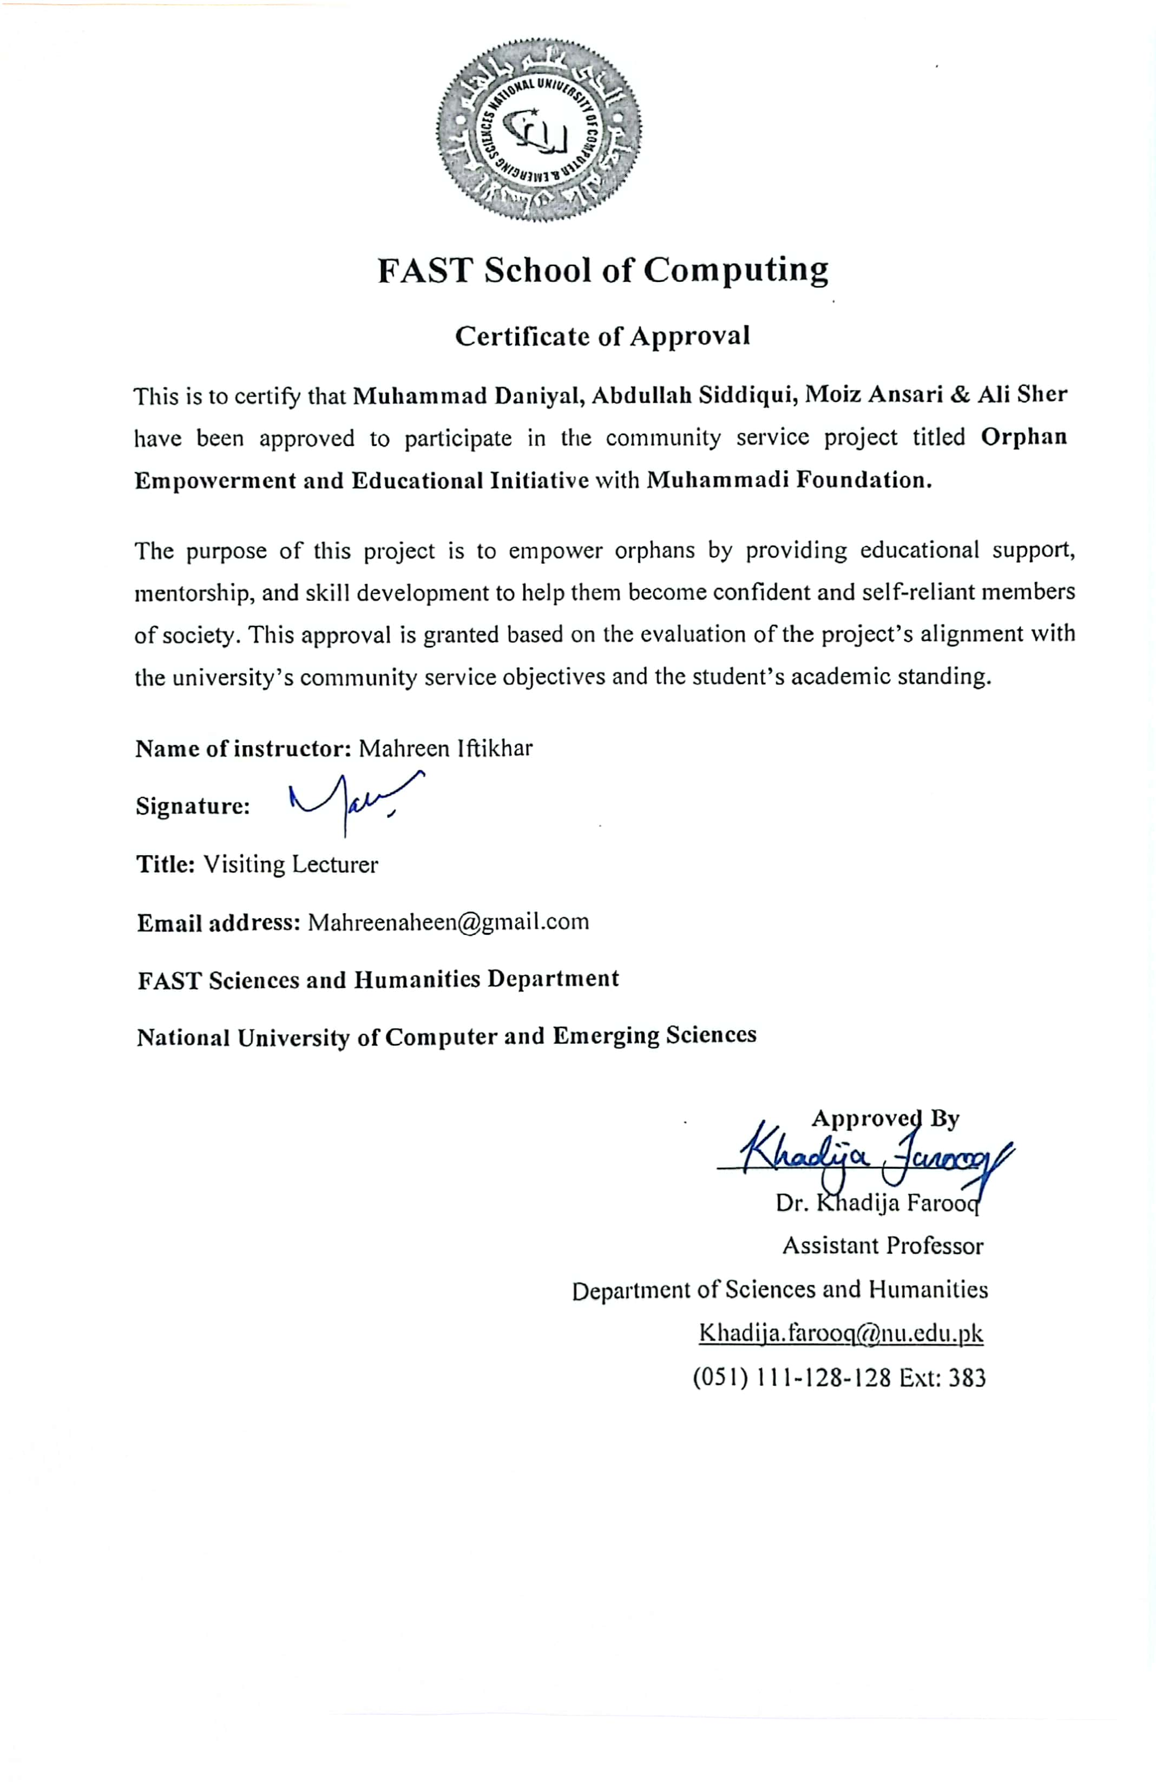

Author’s Declaration

We Moiz Ansari, Ali Sher, Muhammad Daniyal & Abdullah Siddiqui, hereby state that our Community service project titled “Empowering and Nurturing Orphans” is our own work and it has not been previously submitted by us for taking partial or full credit for the award of any degree at this university or anywhere else in the world. If our statement is found to be incorrect, at any time even after our graduation, the University has the right to revoke our BSCS degree.


Ali Sher, Moiz Ansari, Muhammad Daniyal & Abdullah Siddiqui

Dated: 24th Nov 2024

Plagiarism Undertaking

We take full responsibility of the work conducted during Community service project titled, “Empowering and Nurturing Orphans”. We solemnly declare that the work presented in the project is done solely by us and our group with no significant help from any other person; however, small help wherever taken is duly acknowledged. We have also written the complete report by ourselves. Moreover, we have not presented this project (or substantially similar work) or any part of the project previously to any other degree awarding institution within Pakistan or abroad.
We understand that the School of Management of National University Computer and Emerging Sciences has zero tolerance policy towards plagiarism. Therefore, we as an author of the above-mentioned thesis solemnly declare that no portion of our report has been plagiarized and any material used in the project from other sources is properly referenced.

Ww further understand that if we are found guilty of any form of plagiarism in our project work even after our graduation, the university reserves the right to revoke our bachelor’s degree.





__________________________________

Ali Sher, Moiz Ansari, Muhammad Daniyal & Abdullah Siddiqui

Dated: 24th Nov 2024

Executive Summary
As per the requirement of our course, our group embarked on a humble endeavor toward the Mohammadi Aghosh Foundation. The orphanage was unanimously decided by our group. We spent some time there, teaching the children and helping them in their various activities while maintaining good relations with the administration. We arranged fun activities besides academic studies and renovated the bedrooms of the orphans. We set up a fundraiser which gathered significant money for the benefit of the children. We also held several talks with administrations regarding the tangible and intangible issues that persisted there such as hygiene and mental relaxation. All in all, it was a healthy and beneficial endeavor which caused several good impacts to everyone involved. We parted with the children by giving them goody bags and gifts. This journey was filled with reflective and emotional moments for our entire group.

Acknowledgement/Dedications
We were not affiliated with any external NGO or association. We did most of the fundraising and worked by ourselves. Only in the case of hiring and guiding the painters for renovation, we collaborated with a friend group from our university who had been volunteering here as well. It was a 50/50 collaboration so that our time could be well managed. Other than that, we did everything ourselves.

List of Contents
Introduction 1
1. Introducing the Community Service Project 1
• Brief History of the Orphanage 1
• Societal Issues and Gaps Being Addressed 1
2. Purpose and Objectives 1
3. Need Assessment 2
4. Significance 2
5. Alignment with SDGs 3
• SDG 1: No Poverty 3
• SDG 4: Quality Education 3
• SDG 3: Good Health and Well-Being 3
• SDG 10: Reduced Inequalities 3
Project Description 3
1. Details of Activities Conducted 3
• Teaching 3
• Distributing Goody Bags 4
• Renovation 4
• Drawing Activities 4
• Providing Jackets 4
2. Research Methodologies 5
1. Primary Research 5
2. Secondary Research 5
Why These Methodologies Were Used 5
3. Tasks Performed 6
1. Teaching 6
2. Distributing Goody Bags 6
3. Renovation 6
4. Drawing Activities 6
5. Providing Jackets 7
4. Timeline 7
Week 1: 7
Weeks 2–3: 7
Week 4: 7
Week 5: 7
Week 6: 7
Ethical Considerations 7
1. Consent and privacy 7
2. Cultural sensitivity 8
3. Creating a Positive environment and sustainability 8
4. Conflicts of interest 9
5. Guidelines and ethical standards 10
Results 10
Impacts 11
1. Major Impact 11
2. Tangible or intangible benefits 11
3. Relation with SDGs 11
Discussion 12
1. Group Experiences 12
2. Challenges Encountered 12
3. Lesson Learnt & Skills Gained 13
4. Effectiveness of Group 14
Recommendation 14
1. Recommendations 14
• Improved Resource Allocation: 14
• Reserved Time for Activities: 14
2. Suggestions 15
• Improving the Educational System: 15
• Hiring Extra Teachers: 15
• Activities Based on Interests: 15
• Emotional Support: 15
Conclusion 16

Introduction

Introducing the Community Service Project
The service project we undertook was titled "Empowering and Nurturing the Orphanage." For this initiative, we chose to work with the Mohammadi Aghosh Foundation, located in Ghauri Town, Islamabad. We selected this orphanage because it is a local institution that is likely to face more challenges and has fewer resources compared to the more prominent and well-known organizations. Our goal was to understand how such a local orphanage operates and to address the challenges it faces.

Brief History of the Orphanage
The Mohammadi Aghosh Foundation has been serving orphans for many years and operates through multiple branches. It is committed to providing a safe environment for underprivileged children while addressing their basic needs.

Societal Issues and Gaps Being Addressed
Our project sought to tackle significant societal issues. One pressing concern is education inequality, as orphans often lack access to quality education due to financial constraints. Many of them are deprived of the essential tools of the modern era, such as mobile phones and computers, which hinder their exposure to technology.

Additionally, mental health is a critical issue for these children. Many orphans endure past traumas and are often treated poorly by society, leaving them feeling excluded and unsupported. Addressing their emotional well-being by fostering a sense of inclusion was a vital component of our project.

Purpose and Objectives
The purpose of our project was to empower orphans by providing practical support to address their needs. This included:
- Assisting them with their studies.
- Providing essentials that they lack due to financial limitations.
- Offering emotional support and fostering a sense of belonging within society.
While society often claims to advocate for empowering orphans, meaningful actions are rare. Our project aimed to bridge this gap by taking tangible steps to improve the lives of these children.

Need Assessment
The orphans we met often struggled with their studies and faced emotional challenges. Recognizing their right to equal opportunities, we felt compelled to support them. During discussions with the orphanage’s head, we identified several pressing issues, such as the lack of adequate food, education, and healthcare, all stemming from insufficient funding.
A significant challenge is the decline in donations, driven by two factors: the rise in fraudulent organizations and the growing materialism in society. This reduction in donations severely impacts organizations like Mohammadi Aghosh Foundation, which are genuinely dedicated to making a difference.

Significance
Our project’s significance lies in its potential to change perceptions and inspire action. By engaging directly with these children, we helped them feel valued and included in society. Observing university students making sincere efforts for underprivileged children may also encourage others to contribute to similar initiatives, breaking the hesitation surrounding charitable work.
For the children, the experience was transformative. It fostered a sense of confidence and motivated them to aim higher in life. They realized that their circumstances do not define their potential, empowering them to strive for success and embrace a brighter future.

Alignment with SDGs
Our project aligned with several United Nations Sustainable Development Goals (SDGs):
- SDG 1: No Poverty
We addressed financial inequalities by supporting underprivileged children and alleviating their financial struggles.
- SDG 4: Quality Education
We focused on improving their educational experience by helping them understand challenging concepts and addressing their academic weaknesses.
- SDG 3: Good Health and Well-Being
We prioritized their well-being by avoiding any purchases or activities that could harm their health. This was a concern shared by both us and the orphanage staff. Unlike some volunteers who opt for low-cost, harmful alternatives, we ensured that all contributions were safe and beneficial.
- SDG 10: Reduced Inequalities
By creating a welcoming and inclusive environment, we helped reduce the feelings of inferiority that these children often face. Our efforts to connect with them on a personal level succeeded in boosting their confidence and self-worth.

Project Description

Details of Activities Conducted
- Teaching
One of our primary activities was teaching the children. We observed significant diversity in their educational levels. Some children in the 4th grade struggled with basic arithmetic, such as addition and subtraction, because they hadn’t attended school before joining the orphanage. They were placed in higher grades due to their age rather than academic capability. On the other hand, some 1st-grade children were well-versed in basic mathematics and other foundational concepts. This diversity made teaching challenging, as we had to cater to varying educational needs within the same group.

- Distributing Goody Bags
During our final visit, we distributed goody bags to the children as a parting gesture. The purpose was to create a memorable and joyous moment for both the children and us. While the items in the bags were modest, we focused on sharing feelings of care and connection, emphasizing the importance of emotional value over materialistic aspects.

- Renovation
Two rooms in the orphanage were in dire need of renovation. These rooms, used as sleeping quarters by the children, required significant improvements to ensure a safe and comfortable environment. Renovation was the most demanding and time-intensive task we undertook. As we were inexperienced in this area, it required extra effort. Initially, we selected Off-White as the paint color, but after consulting with the orphanage staff, we decided on Salsa, respecting their preference.

- Drawing Activities
We organized a drawing activity to encourage creativity among the children, as fostering creativity is vital during their developmental years. Unfortunately, traditional schooling systems often overlook creativity, so we wanted to fill that gap. The activity aimed to enhance their imagination and provide them with an outlet for self-expression.

- Providing Jackets
As winter approached, the orphanage requested winter clothing and tracksuits for the children. We purchased 61 items, including jackets and tracksuits, to fulfill this need. These were procured within budget by sourcing them wholesale from a single shop. This ensured the children would be adequately prepared for the cold season.

Research Methodologies
1. Primary Research
This included direct efforts to understand the challenges faced by the orphanage.
- Observation:
  - Visited the orphanage to assess living conditions, educational challenges, and overall infrastructure.
  - Observed the children’s behavior, emotional well-being, and learning capabilities.
- Interviews and Discussions:
  - Engaged with orphanage staff to understand their needs and priorities.
  - Interacted with children to identify their aspirations and academic gaps.
2. Secondary Research
This involved gathering information to make informed decisions and align our efforts with best practices.
- Literature Review:
  - Researched educational challenges and mental health issues faced by underprivileged children.
  - Studied effective methods for fostering creativity and improving learning outcomes.
- Benchmarking:
  - Reviewed similar community service initiatives to understand impactful strategies.
Why These Methodologies Were Used:
The combination of primary and secondary research ensured that our project was well-informed and tailored to the specific needs of the children and the orphanage. It enabled us to allocate resources effectively and make meaningful contributions.

Tasks Performed

1. Teaching
- Identified children requiring educational assistance.
- Assessed their existing knowledge and educational levels.
- Focused on teaching fundamental concepts in subjects like mathematics.
- Conducted one-on-one sessions to address individual learning gaps.
- Adapted teaching techniques to accommodate varying educational needs.

2. Distributing Goody Bags
- Decided on the contents of the goody bags based on the children’s preferences.
- Purchased and assembled the items for the bags.
- Personally, distributed the goody bags to ensure every child received one.

3. Renovation
- Inspected rooms and identified those requiring renovation.
- Consulted with the orphanage staff about their preferences for paint colors and other details.
- Procured paint, tools, and other materials within budget.
- Arranged painters and supervised the renovation process.
- Completed the renovation by cleaning and organizing the rooms for the children’s use.

4. Drawing Activities
- Set up the area for the drawing activity.
- Provided art supplies, such as drawing sheets, crayons, and pencils.
- Encouraged the children to express themselves creatively.
- Assisted and guided children who were hesitant or needed ideas.

5. Providing Jackets
- Discussed the children’s clothing needs with the orphanage staff.
- Collected donations to finance the purchase.
- Searched for affordable and high-quality wholesale shops.
- Purchased 61 items, including jackets and tracksuits.
- Arranged transportation to deliver the clothing to the orphanage.

Timeline

Week 1:
  - Visited the orphanage to confirm our volunteer work and identify their needs.

Weeks 2–3:
  - Focused on teaching the children, especially as they prepared for upcoming exams.

Week 4:
  - Shifted our efforts to planning the renovation and purchasing winter clothing.

Week 5:
  - Bought the required winter clothes and renovation supplies.

Week 6:
  - Completed the renovation of the rooms.
  - Organized the drawing activity.
  - Distributed goody bags during our final visit.

Ethical Considerations

Consent and privacy
In all facets of our volunteer work at the orphanage, our group built a foundation of consent and respect for one another. This strategy made sure that everything we did, contributed, and interacted with matched the requirements and preferences of the kids and the administration. We created a great and impactful experience for all parties involved by keeping lines of communication open and encouraging teamwork.
We were careful with every resource, gift, and donation we gave to the orphanage.
compared to the Foundation's aims and requirements. By attending to the children's and the organization's most urgent needs, this made sure that our donations were both significant and useful.
For example, we regularly engaged with the administration to confirm the appropriateness and relevance of our support rather than speculating about what could be helpful.
Another important component of our strategy was respect for privacy. We understood how critical it was to protect the children's personal space and dignity. As a show of openness, we shared all photos shot while we were at the orphanage with the kids and staff, obtaining their express permission before doing so.

Cultural sensitivity
Because of the nature of our activity, it was unrelated to politics, religion, or culture. Furthermore, they showed one other the love and care of siblings in spite of their disparate origins and races. This peaceful cohabitation showed that there was no conflict between them because of cultural or ethnic differences. Rather, these distinctions deepened their relationships and enhanced their common experiences. After noticing this, we concluded that bringing up cultural differences would be pointless and possibly detrimental because it might unintentionally draw attention to divisions that the kids themselves were unaware of. Essentially, we demonstrated our dedication to cultural sensitivity by making the conscious decision to uphold and encourage the peace that already existed at the orphanage.

Creating a Positive environment and sustainability
Two major issues that needed to be addressed right once came up during our volunteer experience. The children's too rigorous and strict routine was the first problem. Their education and academic-related activities took up an astounding 90% of their time, leaving them with little time for play, relaxation, and genuine childhood experiences. The youngsters were robbed of vital moments of joy, creativity, and emotional development that are crucial during their formative years, which made this imbalance between work and play worrying.
The foundation's unsanitary conditions were the second problem. The setting was plainly untidy, with cleanliness falling short of acceptable norms. The youngsters were exposed to many health risks, including infections and diseases. Their general well-being and sense of comfort were affected, in addition to their physical health, by the unclean and poorly maintained environment.
To solve these problems, our group developed a collaborative approach. We had several conversations with the administration about the children's rigorous schedule and argued for a more balanced system that would provide the kids more time for leisure and relaxation.
We strongly urged the administration to give cleaning and sanitation within the foundation top priority in order to address the unsanitary conditions. We started by painting the children's rooms as a concrete first step.

Conflicts of interest
The only small conflict of interest we had while volunteering at the orphanage was when we proposed taking the kids to a local park for some downtime. We thought that this kind of excursion would allow the kids to unwind and have fun, providing a much-needed respite from their rigorous academic schedule. The administration, however, was apprehensive since they valued the kids' education and thought that any change to their routine might hinder their academic development.
We acknowledged their viewpoint and tactfully argued for the value of letting kids relax and engage in unrestrained play. Notwithstanding this disagreement, the issue was resolved amicably, and no more arguments surfaced. Aside from this minor incident, our cooperation with the administration went smoothly, and both sides contributed to improving the welfare of the kids.

Guidelines and ethical standards
Our volunteer program was completely autonomous and unaffiliated with any outside organizations or non-governmental organizations. Because of this independence, we were able to establish our own rules and requirements and modify our strategy to better meet the needs of the kids and the institution. We were in charge of planning, carrying out, and supervising every facet of the project since we were the ones who made the decisions.
At the same time, we dealt with the orphanage's management in a kind and competent manner. We acknowledged their authority and made an effort to work together in a manner that complemented their goals and limitations. Throughout our time at the foundation, maintaining a cordial and easy-going relationship with the staff required striking a balance between being friendly to the kids and showing respect for them.

Results
After providing our services at an orphanage, there were several outcomes that we are going to discuss.
- First, the personal experience and skills that we gained from providing our services by conducting studying activities as well as extracurricular activities for the orphans.
- We developed deeper understanding of social issues and how to address them.
- Equipped children with skills of conceptual learning and avoiding rote learning.
- Made children understand the importance of utilizing free time effectively and utilizing it in their hobbies or exploring their hidden talent.
- Organization realized the importance of students’ balancing academic life along with social life.
- By fundraising, we tried our best to foster a sense of community and awareness among the people that orphans are also a part of our community who need our special attention and love.
- People became aware of the challenges that orphans face in our society.

Impacts

1. Major Impact
Everyone participating benefited from the project's significant influence on the neighbourhood. The main beneficiaries were orphans, who received care and opportunity for a better future as well as improvements in their living situations, education, and emotional health.
Administrators also profited because the project reduced their workload by providing more assistance and optimizing procedures.
Through their donations, donors experienced emotional and spiritual fulfilment that strengthened their sense of belonging to the community and their ability to positively impact the world. Project participants had the opportunity to develop both personally and professionally, and their efforts gave them a sense of purpose and appreciation.
All things considered, the project improved lives, fostered a sense of communal support, and united disparate groups.

2. Tangible or intangible benefits
With an emphasis on significant contributions to the orphanage, the project offered several observable advantages. The space was made brighter and more inviting for the kids to live and learn in after the walls were repainted. The orphans received academic support, which helped them lay the groundwork for a better future by providing them with important educational support. The orphanage's financial assistance also helped it maintain operations and meet basic necessities. Together, these initiatives greatly raised the orphans' standard of living and showed how committed the project was to create a long-lasting beneficial influence.

3. Relation with SDGs
A number of SGDs were considered and worked on.
By giving the institution financial support through donations, we did our utmost to combat poverty. Additionally, we offered the kids direction and a basic understanding of money. (A small amount).
Additionally, we made an effort to clean and enhance the unclean and subpar circumstances that were there. We made a concerted effort to persuade the institution of the issues with cleanliness and good hygiene.
We couldn't provide them with a high-quality education in the time we had available. Nevertheless, we made every effort to educate them and inform them of the different opportunities that are available.
The study focused on orphans, a particularly vulnerable demographic, in an effort to lessen inequities. By providing financial, educational, and emotional support, the project helped give these children the opportunity to try to improve their circumstances.

Discussion

Group Experiences
As a group, we did not only complete the tasks but instead we also had a lot of fun and had a great time going to the orphanage and spending time with children. For the first time, we all used to spend time travelling after university hours. When we reached an orphanage, we used to forget all our worries and just focus on the betterment of the children. Their smiles and love towards us will always be unforgettable. But in this journey, we also faced a lot of issues which we also figured out as well.

Challenges Encountered
First, finding the organization seemed a little hectic as we had to go everywhere as a group, and it was difficult as our academic routine was very strict. We visited many organizations in order to provide our social services, but we got rejected as they were not catering for volunteers any more for their project. Apart from that we noticed rude behavior from a head of SOS Village (one of the organizations we visited). Finally, we found a suitable organization “MUHAMMADI AGHOSH” who were looking for volunteers to address their organizational as well as children needs.
Further, when we started working at the orphanage, there were many challenges that we faced and addressed effectively. The challenges are discussed as follows:
- We came to know that there is no playtime of the children except for Sundays and they just study from morning till evening 6 days of the week.
- Students did not have playing equipment or enough stationery that they can do arts with or play in their free time.
- Due to lack of material, it was difficult to conduct arts activities and teaching workshops.
- The renovation process seemed difficult for us as it was our first time doing social work and we did not have any prior experience of painting walls and its whole process.
- Raising funds for the renovation process was difficult as most people were unwilling to donate.
- Choosing painters for painting was difficult as our budget was very low and painters demand was very high.
- The few challenges we faced ourselves were travelling and managing budget and time.
We addressed these challenges as follows:
- We conducted drawing activity for some fun time of the students. The other team visiting there conducted playing activity for them.
- We gave children goody bags containing stationery and colors on our last visit.
- During drawing activity, we distributed pencils and colors among students taken from the orphanage central stationery materials by the permission of head.
- We were guided by our known ones and supported by our relatives as well. One of our team members’ relatives showed interest in helping as they owned a paint shop.
- We tried our best sharing posters on social media and in our relatives and people donated.
- We finally found a suitable painter under our budget through our connections.
- We mutually collaborated and divided our expenses and also took some time out for the weekly tasks.

Lesson Learnt & Skills Gained
These challenges made us learn many lessons and skills. A very important skill that we gained from this social work is how to effectively communicate with others and deliver your message. Apart from that, we gained management skills and learned how to manage a specific project successfully from start till end, managing budget and dealing with the personnel involved. While gaining these skills we also learnt a lot of lessons. One of which is to always remain happy no matter what. As we see those kids happy in their home, it was a wholesome moment. No matter if they are kids but they gave us many reasons for living life.

Effectiveness of Group
Our project successfully met its objectives set at the start of this social work. We wanted to do social work by keeping in view the interest of both organization and the people for whom we are working. Our work successfully considered the needs of both and addressed them. While respecting the organizational rules and regulations, we guided students towards a path of good learning and nurtured them and worked for their better living conditions and standards. In conclusion, the project fulfilled its objectives successfully.
Recommendation
Based on the insights gained during our community service project at the orphanage, several recommendations can be proposed to enhance the impact of similar initiatives in the future:

Recommendations

Improved Resource Allocation:
While our fundraising efforts were successful, future projects could benefit from a more structured approach to identifying specific needs of the orphanage, which we observed they lack. They purely lack the sports facilities, which is a very essential part of their needs. They should be provided with sports facilities, so they are able to exercise, which is beneficial to their health.

Reserved Time for Activities:
On analysis of their schedule, we observed that they have a very hectic schedule. They attend the school in the morning, attend tuition classes after school and after that they have their Quran classes, which bring them to the end of the day. So, in my opinion, every human, either an adult or a child, needs some rest time in which they could rest, talk, play or anything else other than studying. So, their schedule should be organized in such a way that they have their free time to exercise their bodies or give it some rest.

Suggestions

Improving the Educational System:
As there are number of children of different ages, their academic distribution is disturbed. Meanwhile some children are performing well in their academics, some children lack some educational skills according to their age. So, they should be given extra tuition, so they catch up with other children of their age.

Hiring Extra Teachers:
One of the major problems we observed was that some children weren’t getting enough tutoring attention, which led to their academic downfall. There are a total or more than 50 children in the orphanage house, and only one teacher is tutoring them in their tuition time. This causes a lack of attention for those who are academically left behind. So, some other teachers should be provided who can help managing teaching all students efficiently.

Activities Based on Interests:
On the day we conducted some entertaining activities, which included drawing and sketching, the children were very much interested in such activities. Most of them told us that they have a high desire to do painting and drawing, but unfortunately, they lack the resources for such activities. So, they should be provided with the required resources so they can spend their leisure time on such activities, which would eventually turn into their hobby.

Emotional Support:
During our visits to the orphanage house, we observed that on each visit, their faces light up with pure joy when they see us. This means the affection we showed meant a lot to them and they may lack love and affection from the members of the organization. So, the members of the organization should be convinced to treat the children with pure affection. On the other hand, groups of students should keep visiting them to prevent them feeling deprived of emotional support.
Conclusion
Our community service project at the orphanage successfully achieved its primary objectives of empowering the children through education, engaging them in entertaining activities, and raising funds to support their daily needs. Through the interactive sessions, we were able to strengthen the weak areas in the academic backgrounds of some children and provide them with additional knowledge. The activities organized promoted creativity, joy, and teamwork among the children, further enhancing their learning experiences. Finally, the renovation of their rooms and the winter clothes provided through our fundraising efforts will help improve their quality of life in the near future.
Overall, the project not only improved the children's lives but also taught us important lessons about responsibility, compassion, and teamwork. This experience emphasized the significance of addressing the needs of neglected regions of society and highlighted the necessity of education as a developing tool for sustainable community growth.

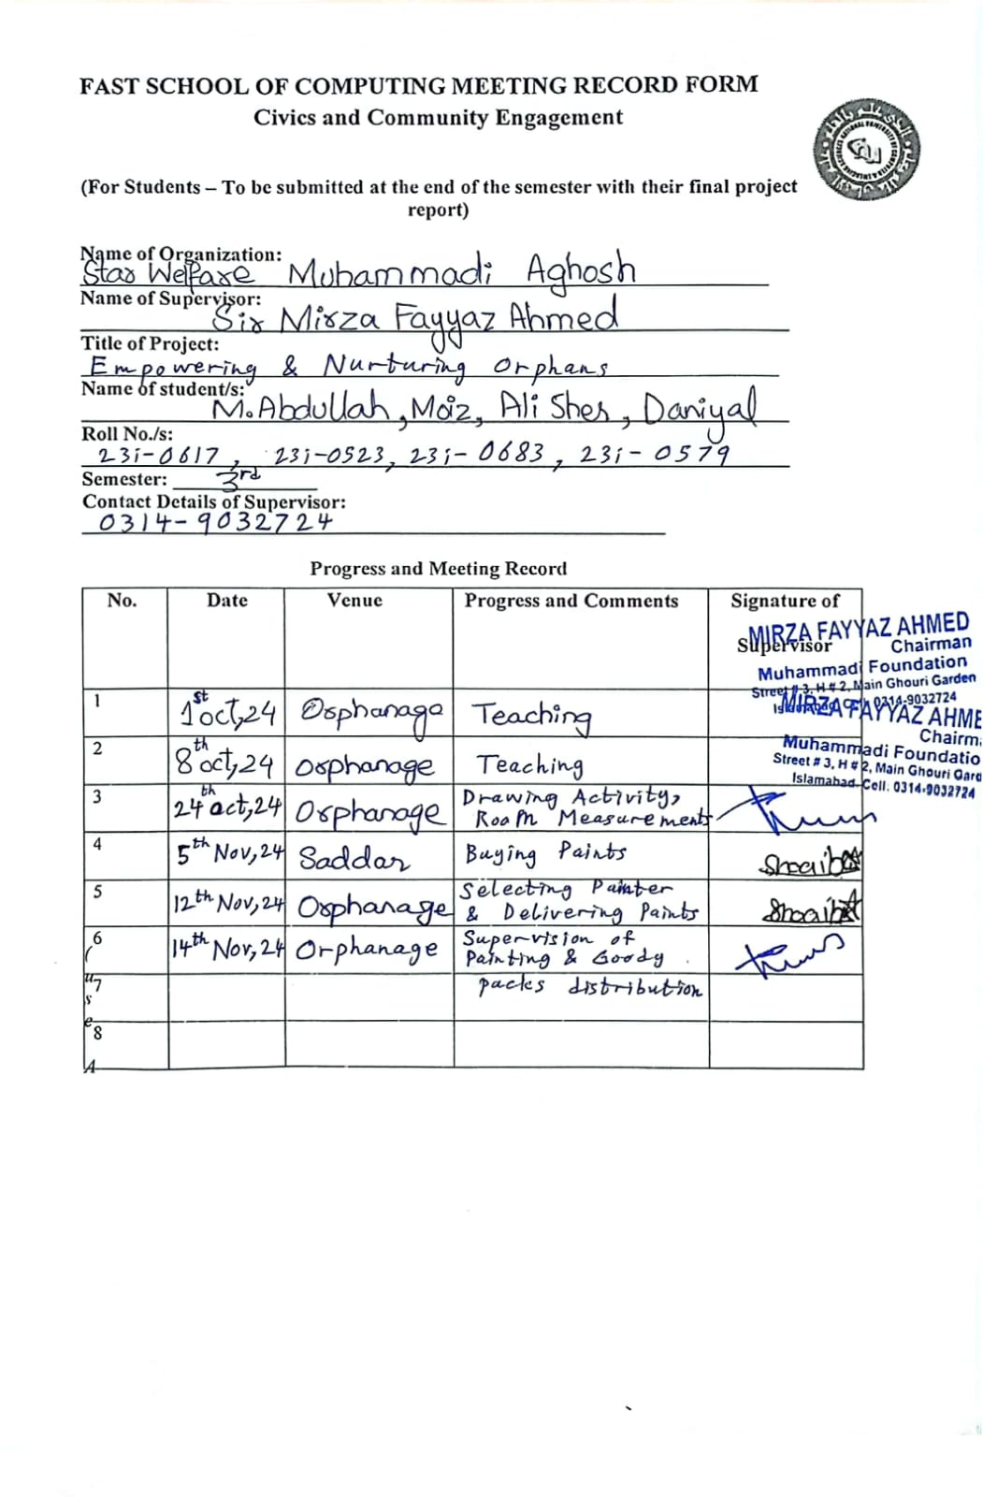
Instructor Name: Mehreen Iftikhar
Email: mehreen.v@isb.nu.edu.pk

